**QUESTION:**

2. https://medium.com/@reach2arunprakash/guvi-zen-class-find-the-culprits-and-nail-them-9ee6c67c44fb

Find the culprit

fix.html

<!DOCTYPE html>

<html>

<body>

<script>

alert( “I’m JavaScript!’);

</script>

Whats the error in this ?

</body>

</html>

CODE:

<script>

alert( "I’m JavaScript!");

</script>

OUTPUT:

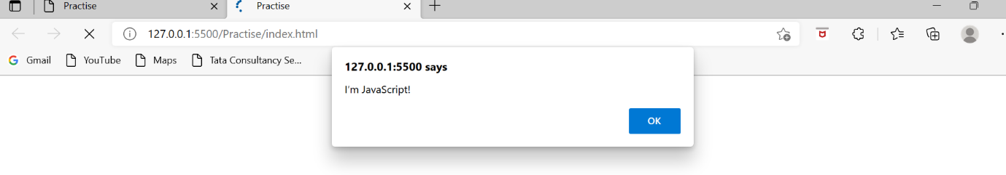

— — — — — — — — — — — — — — — — — — — — — — — — — — — — — — -

Find the culprit and invoke the alert

fix.html

<!DOCTYPE html>

<html>

<body>

<script src=”script.js”></script>

</body>

</html>

scripts.js

alert(“I’m invoked!”);

CODE:

  <body >

    <script src="script.js"></script>

</body>

alert("I’m invoked!");

OUTPUT:

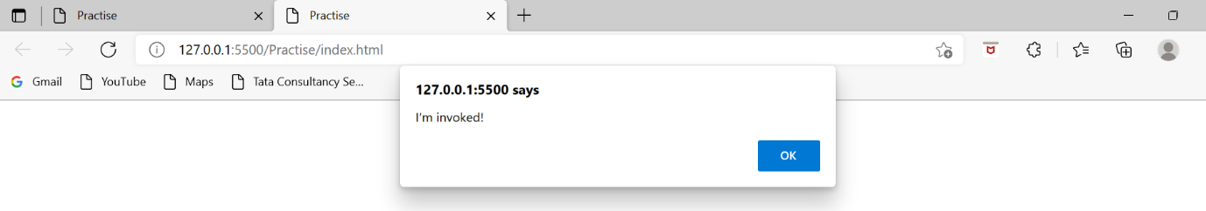

— — — — — — — — — — — — — — — — — — — — — — — — — — — — — — -

**Explain the below how it works**

explain.html

<!DOCTYPE html>  
<html>  
<body>  
 <script src=”script.js”></script>  
</body>  
</html>

script.js

alert("I'm JavaScript!");  
alert('Hello') // this line is not having semicolon  
alert(`Wor  
 ld`)  
alert(3 +  
1  
+ 2); // this is multiple line code and its working

ANSWER:

Semi colon is not required for javascript programming. It is mostly used to make code more readable.

We can have multi line code in javascript. It is considered best practise to break long lines of code.

— — — — — — — — — — — — — — — — — — — — — — — — — — — — — — -

**Fix the below to alert**Guvi geek

fix.html

<!DOCTYPE html>  
<html>  
<body>  
 <script src=”script.js”></script>  
</body>  
</html>

script.js

let admin=9, fname=10.5;   
fname = "Guvi";  
lname = "geek"  
admin = fname+lname;alert( admin ); // "Guvi geek"

CODE:

let admin=9, fname=10.5;

fname = "Guvi";

lname = "geek"

// admin = fname+" "+lname;

admin = `${fname} ${lname}`;

alert( admin ); // "Guvi geek"

OUTPUT:

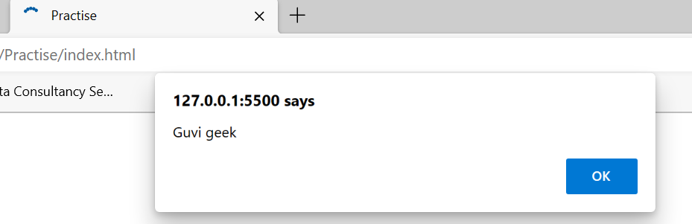

— — — — — — — — — — — — — — — — — — — — — — — — — — — — — — -

**Fix the below to alert**hello Guvi geek

fix.html

<!DOCTYPE html>  
<html>  
<body>  
 <script src=”script.js”></script>  
</body>  
</html>

script.js

let fname=10.5;   
fname = "Guvi";  
lname = "geek"

let name = fname+lname;

alert( 'hello ${name}' );

CODE:

let fname=10.5;

fname = "Guvi";

lname = "geek"

let name = fname+" "+lname;

alert( `hello ${name}` );

OUTPUT:

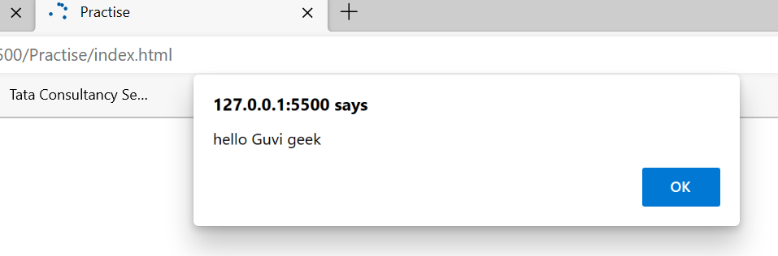

— — — — — — — — — — — — — — — — — — — — — — — — — — — — — — -

**Fix the below to alert sum of two numbers**

fix.html

<!DOCTYPE html>  
<html>  
<body>  
 <script src=”script.js”></script>  
</body>  
</html>

script.js

let a = prompt("First number?");  
let b = prompt("Second number?");  
alert(a + b);

CODE:

let a = prompt("First number?");

let b = prompt("Second number?");

alert(Number(a) + Number(b));

OUTPUT:

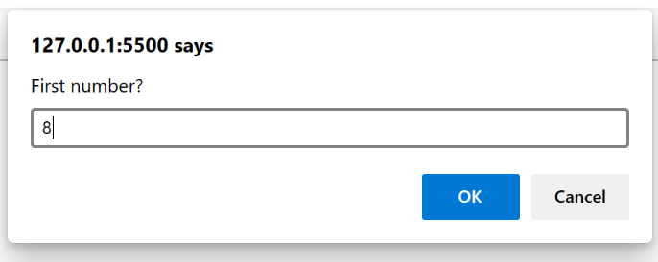 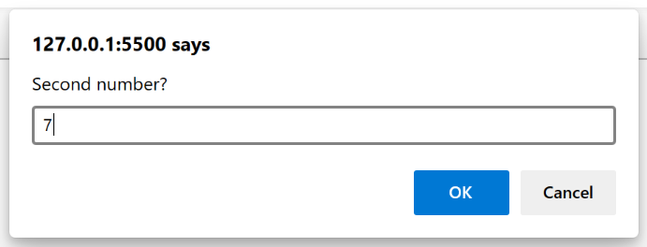

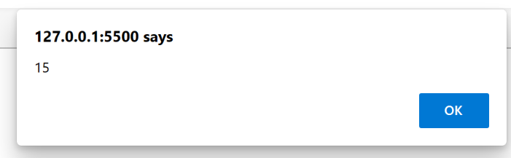

— — — — — — — — — — — — — — — — — — — — — — — — — — — — — — -

**If you run the below scritpt you will get “**Code is Blasted**”** **Explain Why the Code is blasted and how to diffuse it and get “**Diffused**”.**

fix.html

<!DOCTYPE html>  
<html>  
<body>  
 <script src=”script.js”></script>  
</body>  
</html>

script.js

var a = "2" > "12";//Don't touch below this  
if (a) {  
 console.log("Code is Blasted")  
}  
else  
{  
 console.log("Diffused")   
}

CODE:

var a = "2" > "2";//Don't touch below this

if (a) {

  console.log("Code is Blasted")

}

else

{

  console.log("Diffused")

}

OUTPUT:

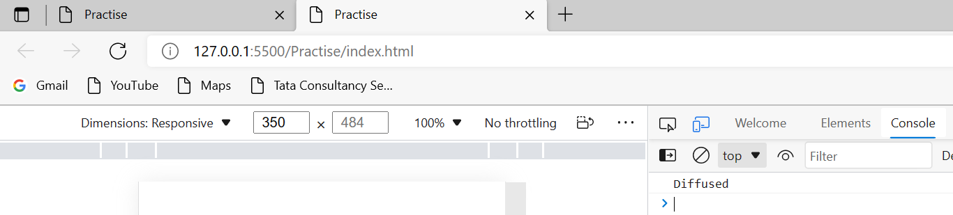

When value of a becomes 0 the condition will become false and code under else will be executed.

— — — — — — — — — — — — — — — — — — — — — — — — — — — — — — -

**How to get the success in console.**

fix.html

<!DOCTYPE html>  
<html>  
<body>  
 <script src=”script.js”></script>  
</body>  
</html>

script.js

let a = prompt("Enter a number?");

//Don't modify any code below this

if (a) {  
 console.log( 'OMG it works for any number inc 0' );  
}  
else  
{  
 console.log( "Success" );  
}

CODE:

let a = prompt("Enter a number?");

//Don't modify any code below this

if (Number(a)) {

 console.log( 'OMG it works for any number inc 0' );

}

else

{

 console.log( "Success" );

}

OUTPUT:

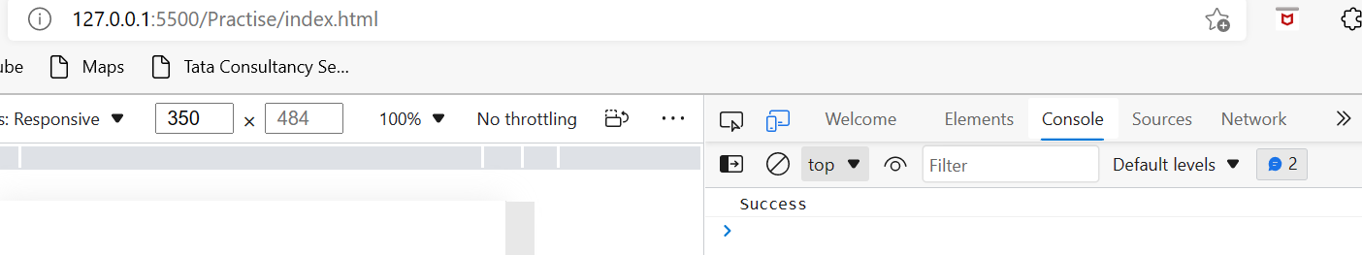

— — — — — — — — — — — — — — — — — — — — — — — — — — — — — — -

**How to get the correct score in console.**

fix.html

<!DOCTYPE html>  
<html>  
<body>  
 <script src=”script.js”></script>  
</body>  
</html>

script.js

let value = prompt('How many runs you scored in this ball');  
if (value === 4) {  
 console.log("You hit a Four");  
} else if (value === 6) {  
 console.log("You hit a Six");  
} else {  
 console.log("I couldn't figure out");  
}

CODE:

let value = prompt('How many runs you scored in this ball');

if (value == 4) {

      console.log("You hit a Four");

} else if (value == 6) {

      console.log("You hit a Six");

} else {

      console.log("I couldn't figure out");

}

OUTPUT:

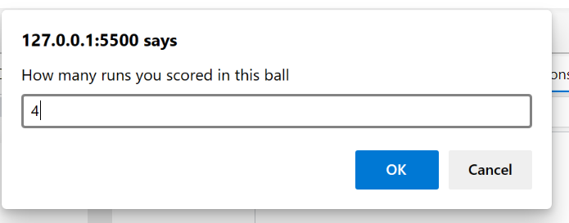

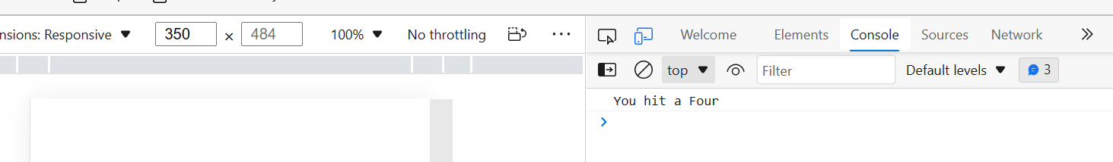

— — — — — — — — — — — — — — — — — — — — — — — — — — — — — — -

**Fix the code to welcome the Employee**

fix.html

<!DOCTYPE html>  
<html>  
<body>  
 <script src=”script.js”></script>  
</body>  
</html>

script.js

let login = 'Employee';  
let message = (login == 'Employee') ? :  
 (login == 'Director') ? 'Greetings' :  
 (login == '') ? 'No login' :  
 '';console.log(message);

CODE:

let login = 'Employee';

let message = (login == 'Employee') ? 'Greetings':'No login';

console.log(message);

OUTPUT:

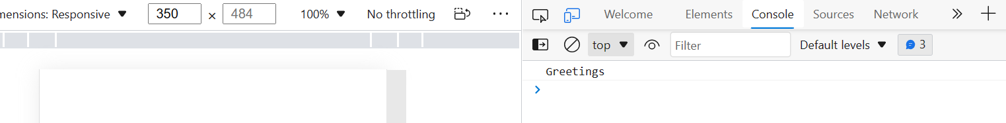

— — — — — — — — — — — — — — — — — — — — — — — — — — — — — — -

**Fix the code to welcome the boss**

fix.html

<!DOCTYPE html>  
<html>  
<body>  
 <script src=”script.js”></script>  
</body>  
</html>

script.js

// You cant change the value of the msg  
let message;if (null || 2 || undefined )  
{  
 let message = "welcome boss";  
}  
else  
{  
 let message = "Go away";  
}  
 console.log(message);

CODE:

// You cant change the value of the msg

let message;

if ( message===null || message===2 || message===undefined)

{

  message = "welcome boss";

}

else

{

  message = "Go away";

}

  console.log(message);

OUTPUT:

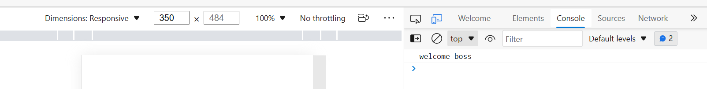

— — — — — — — — — — — — — — — — — — — — — — — — — — — — — — -

**Fix the code to welcome the boss**

fix.html

<!DOCTYPE html>  
<html>  
<body>  
 <script src=”script.js”></script>  
</body>  
</html>

script.js

let message;  
let lock = 2;//Dont change any code below this if (null || lock || undefined )  
{  
 message = "Go away";  
}  
else  
{  
 message = "welcome";  
}  
 console.log(message);

CODE:

let message;

let lock = 0;

//Dont change any code below this

if (null || lock || undefined )

{

  message = "Go away";

}

else

{

 message = "welcome";

}

  console.log(message);

OUTPUT:

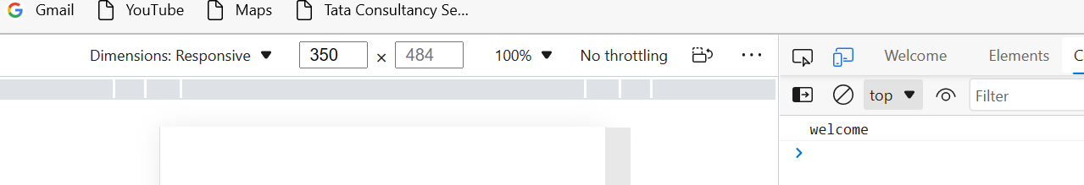

— — — — — — — — — — — — — — — — — — — — — — — — — — — — — — -

**Fix the code to welcome the boss**

fix.html

<!DOCTYPE html>  
<html>  
<body>  
 <script src=”script.js”></script>  
</body>  
</html>

script.js

let message;  
let lock = 2;//Dont change any code below thisif (lock && " " || undefined )  
{  
 message = "Go away";  
}  
else  
{  
 message = "welcome";  
}  
console.log(message);

CODE:

let message;

let lock = 0;

//Dont change any code below this

if (lock && " " || undefined )

{

  message = "Go away";

}

else

{

 message = "welcome";

}

console.log(message)

OUTPUT:

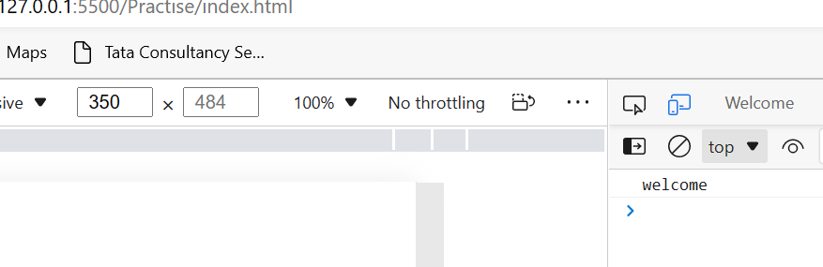

— — — — — — — — — — — — — — — — — — — — — — — — — — — — — — -

**Change the code to print**

3

2

1

fix.html

<!DOCTYPE html>  
<html>  
<body>  
 <script src=”script.js”></script>  
</body>  
</html>

script.js

//You can change only 2 characterslet i = 3;while (i) {  
 console.log( --i );  
}

CODE:

//You can change only 2 characters

let i = 3;

while (i) {

  console.log( i-- );

}

OUTPUT:

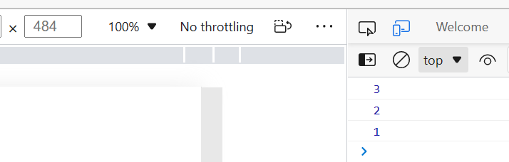

— — — — — — — — — — — — — — — — — — — — — — — — — — — — — — -

**Change the code to print 1 to 10 in 4 lines**

fix.html

<!DOCTYPE html>  
<html>  
<body>  
 <script src=”script.js”></script>  
</body>  
</html>

script.js

let num = 1  
console.log(num)  
num += 1  
console.log(num)  
num += 1  
console.log(num)  
num += 1  
console.log(num)  
num += 1  
console.log(num)  
num += 1  
console.log(num)  
num += 1  
console.log(num)  
num += 1  
console.log(num)  
num += 1  
console.log(num)  
num += 1  
console.log(num)

CODE:

let num = 1

console.log(num)

num += 2

console.log(num-1,num)

num += 3

console.log(num-2,num-1,num)

num += 4

console.log(num-3,num-2,num-1,num)

OUTPUT:

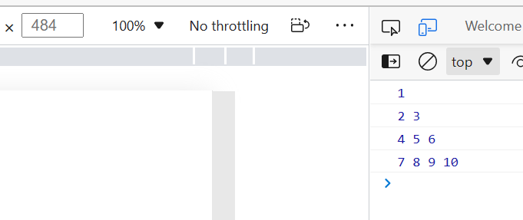

— — — — — — — — — — — — — — — — — — — — — — — — — — — — — — -

**Change the code to print even numbers**

fix.html

<!DOCTYPE html>  
<html>  
<body>  
 <script src=”script.js”></script>  
</body>  
</html>

script.js

//You are allowed to modify only one character for (let num = 2; num <= 20; num += 1) {  
 console.log(num)  
}

CODE:

//You are allowed to modify only one character

for (let num = 2; num <= 20; num += 2) {

    console.log(num)

  }

OUTPUT:

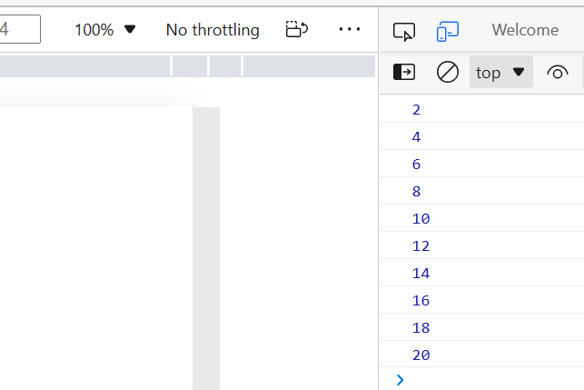

— — — — — — — — — — — — — — — — — — — — — — — — — — — — — — -

**Change the code to print all the gifts**

fix.html

<!DOCTYPE html>  
<html>  
<body>  
 <script src=”script.js”></script>  
</body>  
</html>

script.js

let gifts = ["teddy bear", "drone", "doll"];for (let i = 0; i < 3; i++) {  
 console.log('Wrapped ${'gifts[i]'} and added a bow!');  
}

CODE:

let gifts = ["teddy bear", "drone", "doll"];

for (let i = 0; i < 3; i++) {

  console.log(`Wrapped ${gifts[i]} and added a bow!`);

}

OUTPUT:

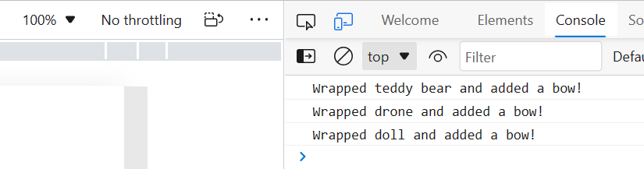

— — — — — — — — — — — — — — — — — — — — — — — — — — — — — — -

**Fix the code to disarm the bomb.**

fix.html

<!DOCTYPE html>  
<html>  
<body>  
 <script src=”script.js”></script>  
</body>  
</html>

script.js

let countdown = 100;while (countdown > 0) {  
 countdown--;  
 if(countdown == 0)  
 {  
 console.log("bomb triggered");  
 }  
}

CODE:

let countdown = 100;

while (0) {

  countdown--;

  if(countdown == 0)

  {

   console.log("bomb triggered");

  }

}

— — — — — — — — — — — — — — — — — — — — — — — — — — — — — — -

Whats the msg printed and why?

var lemein = “0”;  
var lemeout = 0;  
var msg = “”;if (lemein) {  
 msg += “hi”;  
 }if (lemeout) {  
 msg += ‘Hello’;  
}console.log(msg);

OUTPUT: hi

REASON:

The number 0 means false so “hello” is not printed and “hi” is printed.

— — — — — — — — — — — — — — — — — — — — — — — — — — — — — — -